TCGA-PRAD Differential Expression analysis and Enrichment analysis - Ravindu
Differential expression analysis was carried out using generalized linear modelling of RNA-seq data from the TCGA-PRAD dataset. Lowly expressed were first filled out using a threshold of log2cpm > 1. This resulted in reduction of candidate genes from around 60,000 to just 17,000.
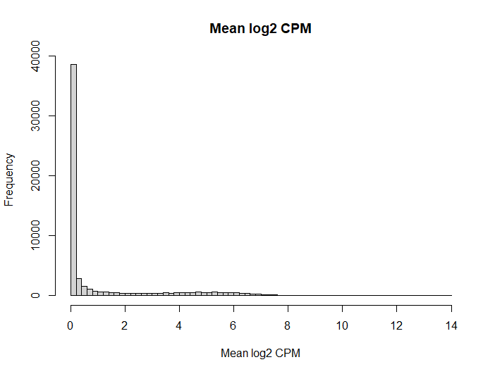
Then generalized linear modelling was carried out based on Normal tissue and primary tumor conditions. 1930 DEGs were identified based of the logCPM and p value cutoffs, of which the top 10 differentially expressed genes and their features are shown below.
Gene_id | Logfc | Logcpm | F | Pvalue | Fdr | Entrezgene_id | Hgnc_symbol | Description
Ensg00000168389 | -6.01392 | 3.524428 | 1454.311 | 4.14e-157 | 6.52e-153 | 84879 | Mfsd2a | Mfsd2 lysolipid transporter a, lysophospholipid
Ensg00000188488 | -6.8017 | 4.268651 | 1399.269 | 9.02e-154 | 7.10e-150 | 5104 | Serpina5 | Serpin family a member 5
Ensg00000085662 | -3.91701 | 5.777932 | 1056.986 | 1.06e-130 | 5.58e-127 | 231 | Akr1b1 | Aldo-keto reductase family 1 member b
Ensg00000197705 | -4.26938 | 1.529424 | 937.8938 | 3.67e-121 | 1.44e-117 | 57565 | Klhl14 | Kelch like family member 14
Ensg00000103034 | -3.38479 | 3.04985 | 823.3196 | 9.13e-112 | 2.87e-108 | 65009 | Ndrg4 | Ndrg family member 4
Ensg00000095713 | -4.34583 | 2.573196 | 782.8729 | 4.04e-108 | 1.06e-104 | 55118 | Crtac1 | Cartilage acidic protein 1
Ensg00000270885 | -3.50885 | 2.10812 | 761.4903 | 3.53e-106 | 7.93e-103 | 91608 | Rasl10b | Ras like family 10 member b
Ensg00000109667 | -2.72879 | 2.382963 | 650.7333 | 1.34e-95 | 2.63e-92 | 56606 | Slc2a9 | Solute carrier family 2 member 9
Ensg00000104267 | -4.47815 | 2.845228 | 631.7797 | 1.14e-93 | 2.00e-90 | 760 | Ca2 | Carbonic anhydrase 2
Ensg00000159763 | -7.39332 | 6.566194 | 627.1622 | 3.15e-93 | 4.95e-90 | 5304 | Pip | Prolactin induced protein

Then, enrichment analysis was carries out on these DEGs to identify the top enriched pathways. There were 44 pathways that were significantly enriched, through these DEGs, of which the topmost are displayed in dot plots and enrichment map below. 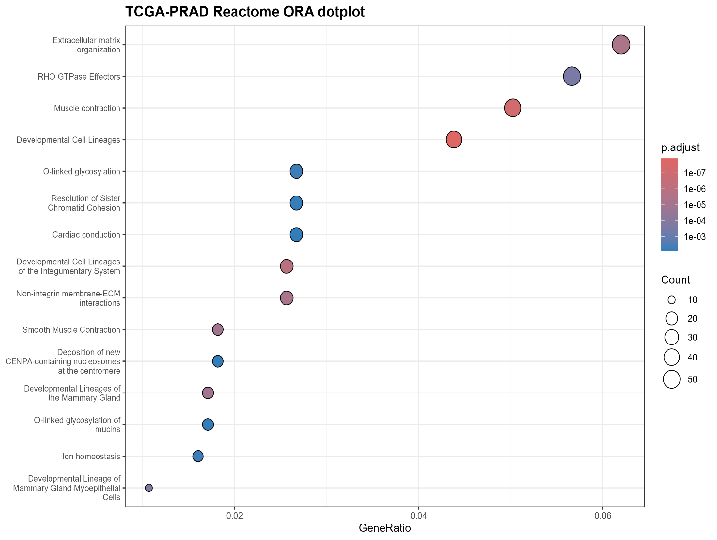
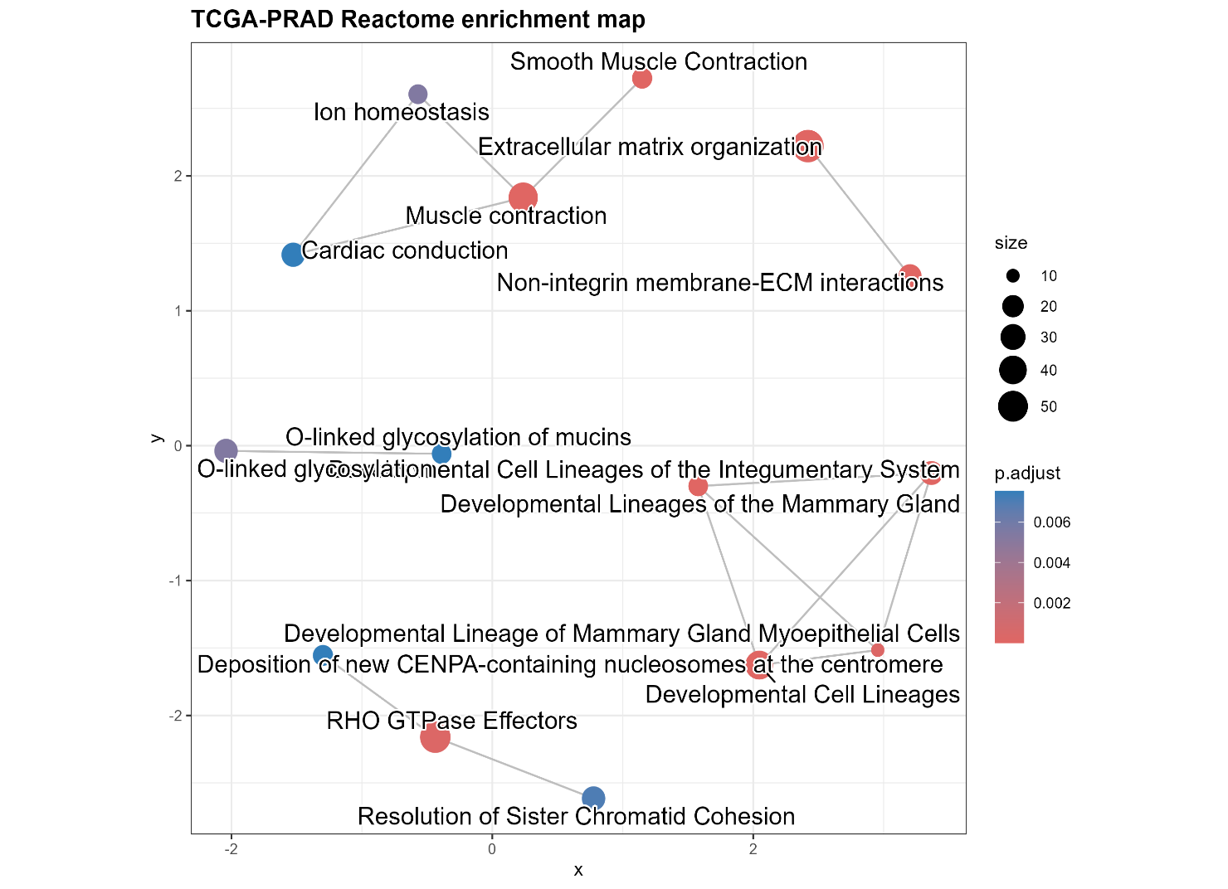
Description | GeneRatio | BgRatio | RichFactor | FoldEnrichment | zScore | pvalue | p.adjust | qvalue
Developmental Cell Lineages | 41/936 | 153/11287 | 0.267974 | 3.231433 | 8.356428 | 7.14E-12 | 1.23E-08 | 1.23E-08
Muscle contraction | 47/936 | 205/11287 | 0.229268 | 2.764691 | 7.667494 | 8.20E-11 | 7.07E-08 | 7.07E-08
Developmental Cell Lineages of the Integumentary System | 24/936 | 73/11287 | 0.328767 | 3.964524 | 7.641048 | 1.93E-09 | 1.11E-06 | 1.11E-06
Extracellular matrix organization | 58/936 | 321/11287 | 0.180685 | 2.178841 | 6.443185 | 9.62E-09 | 4.15E-06 | 4.15E-06
Non-integrin membrane-ECM interactions | 24/936 | 80/11287 | 0.3 | 3.617628 | 7.06521 | 1.50E-08 | 5.17E-06 | 5.17E-06
Developmental Lineages of the Mammary Gland | 16/936 | 40/11287 | 0.4 | 4.823504 | 7.284337 | 4.12E-08 | 1.05E-05 | 1.05E-05
Smooth Muscle Contraction | 17/936 | 45/11287 | 0.377778 | 4.555532 | 7.186308 | 4.27E-08 | 1.05E-05 | 1.05E-05
Developmental Lineage of Mammary Gland Myoepithelial Cells | 10/936 | 20/11287 | 0.5 | 6.02938 | 6.769274 | 1.25E-06 | 0.00027 | 0.00027
RHO GTPase Effectors | 53/936 | 327/11287 | 0.16208 | 1.954478 | 5.266855 | 1.51E-06 | 0.000289 | 0.000289
O-linked glycosylation | 25/936 | 126/11287 | 0.198413 | 2.392611 | 4.726943 | 3.24E-05 | 0.005383 | 0.005383
Ion homeostasis | 15/936 | 56/11287 | 0.267857 | 3.230025 | 5.030502 | 3.43E-05 | 0.005383 | 0.005383
Resolution of Sister Chromatid Cohesion | 25/936 | 129/11287 | 0.193798 | 2.336969 | 4.592401 | 4.89E-05 | 0.007019 | 0.007019
O-linked glycosylation of mucins | 16/936 | 65/11287 | 0.246154 | 2.96831 | 4.785551 | 5.87E-05 | 0.007544 | 0.007544
Cardiac conduction | 25/936 | 132/11287 | 0.189394 | 2.283856 | 4.461546 | 7.25E-05 | 0.007544 | 0.007544

